**MKEL 1123: BLINKY APP**

**Prepared by:**

**Wu Junjie**

**Kayongo David**

**Alinda Arnold.**

1. [kayongopique/MKEH1123Workspace (github.com)](https://github.com/kayongopique/MKEH1123Workspace/tree/master) . Click the above link and download the project files from GitHub. Or clone the git repo using git clone [place below ULI here] <https://github.com/kayongopique/MKEH1123Workspace.git>
2. Download STM32CubeIDE studio and open a new project. You will be faced by screen below to choose a board. Choose NUCLEO-F446RE and click next. see figure 1.
3. In next pop-up window choose the name of the project. [Project name: Blinky. See figure 2.
4. The circuit board LED can be controlled by PIN 5 as indicated figure 3.
5. Then click the device configuration tool code generation to generate set up code the selected circuit board.
6. Go to the while loop section where we write the code to toggle the LED on the circuit board ON for 500ms and OFF for 1000ms. See figure 4.
7. DEMO video on YouTube link <https://youtu.be/dHmQ6E1SGh8> .

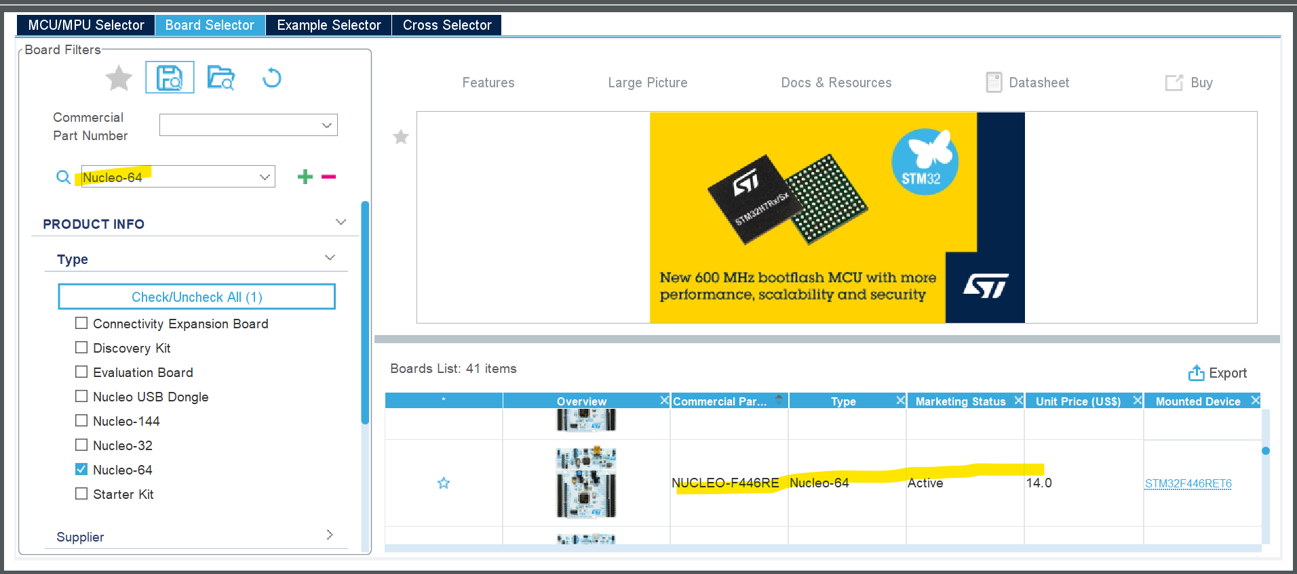

Figure 1 choose board

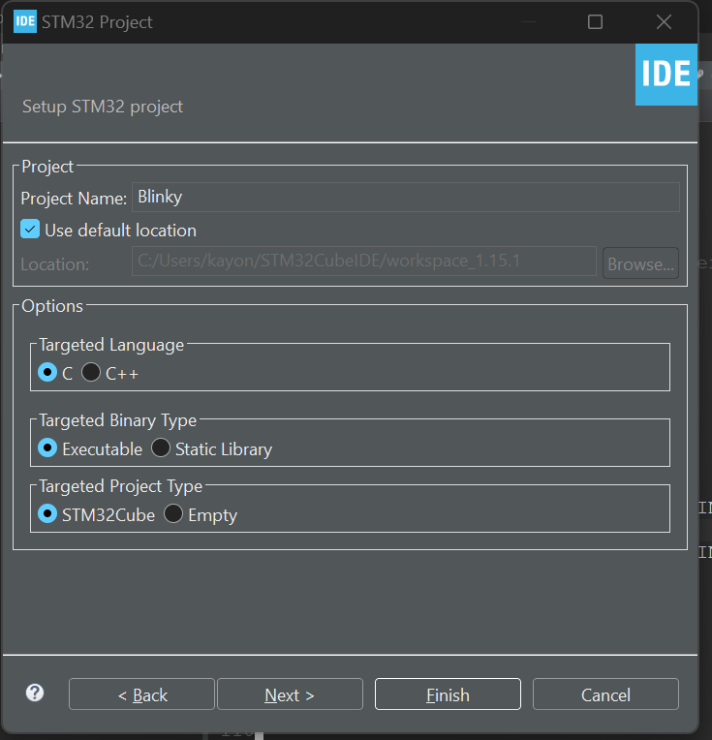

Figure 2 Coose project name as blinky

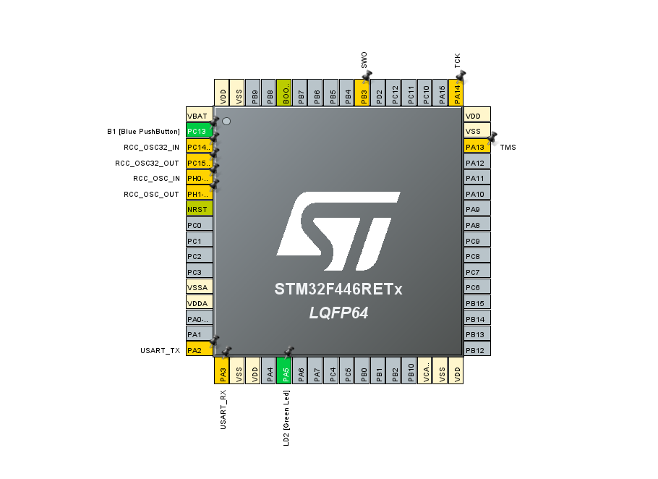

Figure 3 circuit board overview

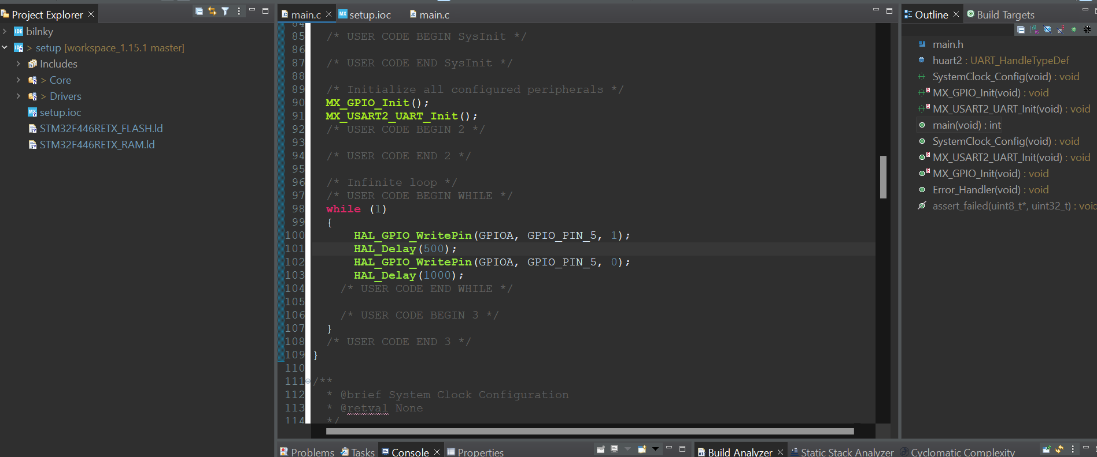

Figure 4 code to toggle the LED